**LIBRARY MANAGEMENT SYSTEM**

* **Diagram:**

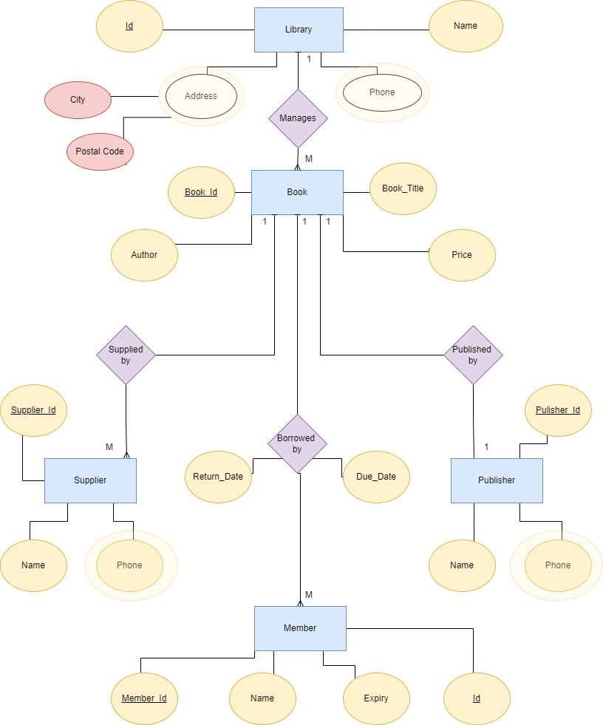

* **Insights from the diagram:**

1. One publisher publishes one book
2. Multiple suppliers can supply one book
3. One book is read by multiple members
4. One Library manages many books

* **Entities:**

1. Book
2. Supplier
3. Publisher
4. Member
5. Library

**4) Defining Attributes:**

1. **Publisher:**
2. Publisher_Id(Key Attribute)
3. Name
4. Address

**b) Supplier:**

1. Supplier_Id(Key Attribute)
2. Name
3. Address

**c) Book:**

1. Book_Id(Key Attribute)
2. Title
3. Author
4. Price

**d) Member:**

1. Member_Id(Key Attribute)
2. Name
3. Expiry
4. Address

**e) Library:**

1. Name
2. Address
3. Phone